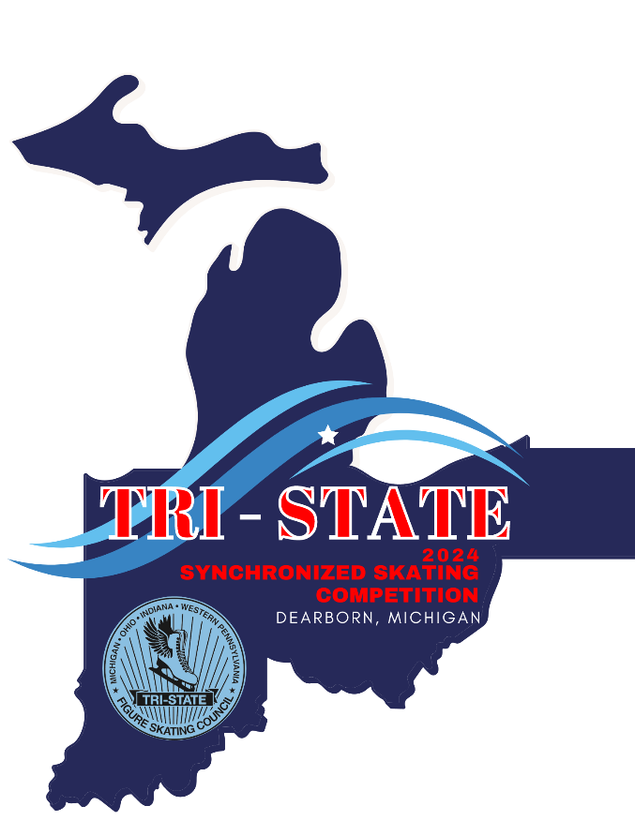

TRI STATE SYNCHRONIZED SKATING COMPETITION
FEBRUARY 10, 2024
Hosted by the Dearborn Figure Skating Club
Dearborn Ice Skating Center – Dearborn, Michigan

​​I. COMPETITION OVERVIEW
Tri State Synchronized Skating Competition will be conducted in accordance with the rules and regulations of U.S. Figure Skating, as set forth in the current rulebook, and/or current Compete USA handbook as well as any pertinent updates that have been posted on the U.S. Figure Skating website.

This competition is open to all eligible, restricted, reinstated or readmitted persons as defined by the Eligibility Rules.

Skaters must be a currently registered member of a U.S. Figure Skating member club, Learn to Skate USA® member, a collegiate club or who is an individual member in accordance with the current rulebook. For non-U.S. citizens, please refer to the rulebook for more information.

II. ELIGIBILITY
- For synchronized skating teams, moves-in-the-field test requirements are as of the entry deadline.

EVENTS OFFERED
Program requirements for the events listed below can be found here: usfigureskating.org – Skate – Compete – Program Requirements
SYNCHRONIZED SKATING | JUDGING | Team Fee | Skater Fee
Aspire 1 | 6.0 | $90 | $15
Aspire 2 | 6.0 | $90 | $15
Aspire 3 | 6.0 | $90 | $15
Aspire 4 | 6.0 | $90 | $15
Preliminary | IJS | $130 | $25
Pre-Juvenile | IJS | $130 | $25
Open Juvenile | IJS | $130 | $25
Juvenile | IJS | $130 | $25
Intermediate | IJS | $130 | $25
Novice | IJS | $130 | $25
Junior Short Program | IJS | $130 | $25
Junior Free Skate | IJS | $130 | $25
Junior Combined (Short & Free) | IJS | $230 | $25
Senior Short Program | IJS | $130 | $25
Senior Free Skate | IJS | $130 | $25
Senior Combined (Short & Free) | IJS | $230 | $25
Senior Elite 12 Short Program | IJS | $130 | $25
Senior Elite 12 Free Skate | IJS | $130 | $25
Senior Elite 12 Combined (Short & Free) | IJS | $130 | $25
Collegiate | IJS | $130 | $25
Adult | IJS | $130 | $25
Masters | IJS | $130 | $25
Open Collegiate | 6.0 | $130 | $25
Open Adult | 6.0 | $130 | $25
Open Masters | 6.0 | $130 | $25

OUR COMMUNITY
U.S. Figure Skating is dedicated to fostering a culture of belonging and community that is welcoming for all individuals. We are committed to championing diversity, equity and inclusion and understand its value in combating discrimination and challenging inequalities necessary to develop champions both on and off the ice. We are actively working toward developing equitable practices and policies that foster safety and empower all individuals to authentically pursue their unique path in all areas of our sport. We stand firmly on the belief that our members are the most important asset to our organization and that our differences are meaningful and strengthen our sport. We believe that skating is for everyone.
NON-DISCRIMINATION
U.S. Figure Skating commits in policy, principle and practice to sustain a non-discriminatory approach on and off the ice for all members. We strive to provide equal opportunity for all despite their varied backgrounds, experiences and identities, and want all members to feel values and respected at every level of organization. U.S. Figure Skating’s SkateSafe® Program received, investigates and addresses allegations of discrimination or harassment throughout its membership and the organization. Please refer to the SkateSafe® Program Handbook for further definition of harassment, discrimination and abuse.

By attending this event, all participants are willingly committing to upholding U.S. Figure Skating’s Code of Ethics (GR 1.01) and Code of Conduct (GR 1.02), as detailed within the U.S. Figure Skating Rulebook.

To report a concern of discrimination or harassment to U.S. Figure Skating, please visit www.USFigureSkating.org/SkateSafe or email SkateSafe@USFigureSkating.org.

COMPLIANCE
For full details about participant compliance requirements, refer to the U.S. Figure Skating SkateSafe® webpage: https://www.usfigureskating.org/skatesafe#compliance.

COACHES
To be an eligible coach at a nonqualifying competition, coaches must meet the applicable compliance requirements and verified by U.S. Figure Skating. Coach compliance falls into two categories, Coach Compliance (includes choreographers) and Learn to Skate USA® Instructor Compliance. Details regarding compliance requirements can be found HERE. All compliance requirements must be met at the time of check-in to access the competition, no exceptions.
Coaches of foreign athletes: If you are a coach of a foreign athlete only, you are not subject to U.S. Figure Skating coach compliance and will only be asked to provide a letter of good standing for the federation your athlete represents.

Teams are permitted a maximum of two coaches per registered team.

With EMS, coaches must be included within a skater/team’s registration or updated through their EMS Skater Portal via “My Coaches” or “Team Personnel.” All coaches declared at the time of registration will be included on the registration confirmation email. Note: There is no registration approval process within EMS as the data (membership and test level) is tied to the U.S. Figure Skating database. Non-compliant coaches will receive automated email reminders through the start of the competition.

EMS Coach Resources
- Team Management Guide

TEAM SERVICE PERSONNEL
Teams are permitted a maximum of two team service personnel. Team service personnel must have a green lighted background check and completed SafeSport™ Training. All compliance requirements must be met at the time of check-in to access the competition, no exceptions. Team service personnel is defined as those indicated as a team manager and/or team service personnel planning to attend the competition with the team.
All team personnel and skaters who will need to receive a credential must be listed in the Team Portal for the competition (Team Personnel for coaches and team managers; Competition Roster for skaters and alternates). In order to be added in EMS, the individual must first be added in the team’s profile through Member’s Only.

MANDATORY ATHLETES
Athletes age 18+ as of the competition start date who will be competing on a team (i.e., synchro, ice dance, pairs, shadow dance, theatre, etc.) with at least one Minor Athlete must complete SafeSport™ Training. *
Minor athletes who turn 18 mid-season are encouraged to seek parental consent to take the online SafeSport™ Training early to avoid any disruptions in their ability to participate as the training is required upon turning 18. The athlete will not be compliant until they have completed the training and their Members Only portal reflects completion. Please email skatesafe@usfigureskating.org for instructions or questions regarding parental consent.
III. REGISTRATION INFORMATION
ONLINE REGISTRATION VIA EMS
Online registrations will be accepted via EMS. Payment must be made at the time of registration by credit card only. Each transaction includes a 3% transaction fee.

Registration Deadline: 01/05/2024 at 11:59PM ET
Late Registration Deadline: 01/12/2024 at 11:59PM ET + $25 Late Fee

ONLINE REGISTRATION VIA EMS
All teams are required to register online via the U.S. Figure Skating Event Management System (EMS). Anyone listed as a team manager or coach for a team in their Members Only Team Profile will be able to access the registration system. Registration for the competition is not considered final until online payment has been received. Online payment via credit card is the only form of accepted payment for registration in EMS.
- Go to https://m.usfigureskating.org.
- Use your personal member number and password to login.
- Click the BLUE “EMS Event Management System” button.
- Choose “Competition Registration – Teams” from the menu.
- Select the team you would like to register for competition.
- Click the REGISTER NOW button next to your competition’s name.
NOTE: Only the competitions for which your team(s) are eligible will appear.
- Walk through the on-screen registration process which will include:
  - Team Verification: Confirm the team’s information is accurate.
  - Registration Overview: Review general information about the competition.
  - Event Selection: Confirm the event you are registering the team for is accurate.
  - Competition Roster Selection: Click the “Add Skaters” link. The screen will display all skaters listed in your Main Roster. Check the box next to each skater’s name to add them to the competition roster.
  - Coach Information: Click the “Add Coaches” link. The screen will display all coaches listed in your Team Profile. Check the box next to each coach’s name to add them. Only the coaches who will be attending this competition should be listed. This information can also be updated from your EMS Team Portal. You will only be able to add coaches who are listed in your Team Profile.
  - Team Service Personnel Information: Click the “Add Team Service Personnel” to add attending team service personnel. The screen will display team managers and team service personnel listed in your Team Profile. Check the box next to each name to add them. Only the team service personnel who will be attending this competition should be listed. This information can also be updated from your EMS Team Portal. You will only be able to add team service personnel who are listed in your Team Profile.
- Payment via credit card will be required to complete your registration as it is the only accepted form of payment for registration in EMS. Registrations are not considered complete until an invoice confirmation via email has been received. A 3% processing fee will be assessed at check-out.
NOTE: Payment must be submitted individually for each team’s registration. If you are planning on registering multiple teams in a short period of time, it is recommended that you contact your credit card company to prevent anti-fraud systems from being activated.

FOREIGN SYNCHRO AND THEATRE ON ICE TEAMS
Additional steps are required to complete your registration. For a full guide to registering foreign teams, CLICK HERE. Email productsupport@usfigureskating.org if you require assistance.
MUSIC SUBMISSION/UPLOAD
EMS MUSIC UPLOAD: Competitors participating in events with music are required to upload their music to EMS no later than January 19, 2024 11:59PM ET. After this date, skaters will be locked out of this feature and subject to a $25 late fee. The late fee will automatically be added to each skater's cart who doesn't meet this requirement by the deadline. Late fees will not be removed under any circumstances and must be paid prior to receiving the skater credential onsite.

EMS SKATER MUSIC UPLOAD HOW TO: CLICK HERE
If you need assistance, email productsupport@usfigureskating.org
Competitors must also have available a backup copy of their competition music on a cell phone and it must be immediately available rinkside whenever the skater competes. If the phone does not have the standard round headset connector, an appropriate adapter, such as an Apple Lightning connector or Samsung USB-C adapter is required to be attached. The phone should be presented to the music person with the file ready to play, phone in airplane mode and volume turned to maximum.

PLANNED PROGRAM CONTENT (PPC) SUBMISSION/UPLOAD – FOR IJS EVENTS ONLY
EMS PLANNED PROGRAM CONTENT (PPC) – Competitors participating in IJS events are required to submit PPC in EMS no later than January 19, 2024 11:59PM ET. After this date, skaters will be locked out of this feature in EMS and subject to a $25 late fee. The late fee will automatically be added to each skater’s cart who doesn’t meet this requirement by the deadline. Late fees will not be removed under any circumstances and must be paid prior to receiving the skater credential onsite.
EMS PPC UPLOAD HOW TO: CLICK HERE
If you need assistance, email productsupport@usfigureskating.org
REFUND POLICY
Entry fees will not be refunded after the entry deadline unless the competition is canceled by the host club or venue.

LIABILITY
U.S. Figure Skating, Learn to Skate USA®, the Dearborn Figure Skating Club and the Dearborn Ice Skating Center accept no responsibility for injury or damage sustained by any participant in this competition. This is in accordance with Rule 1600 of the official U.S. Figure Skating Rulebook.

IV. COMPETITION DETAILS
FACILITIES
Tri State Synchronized Skating Competition will be held at the Dearborn Ice Skating Center, 14900 Ford Rd., Dearborn, MI, 48126. There are two (2) NHL regulation size ice surfaces. There are eight locker rooms. Warm up space and time will be incorporated into the schedule for each team. Snack/Concession is available.

LOCKER ROOMS AND CHANGING AREAS
There are eight locker rooms at the Dearborn Ice Skating Center. Locker rooms will be available for changing into/out of costumes and ice skates. All athletes are expected to arrive at the arena with their hair and make-up completed. Locker rooms, public restrooms and spectator stands will not be available for skate bags, hair/makeup application.

The designated team coach, team manager, team service personnel and athletes competing at the skating event are allowed in the Locker Rooms/Changing Area designated for their team. The team coach, team manager, and team service personnel should remove themselves from the Locker Room/Changing Area while any Minor Athlete(s) are actively changing or undressing. All Locker Rooms/Changing Areas will be monitored. If any concerns arise, immediately contact the Locker Room/Changing Area monitor. If there are concerns regarding this policy, an athlete should change prior to arriving at the competition. The use of any recording and photographic devices inside a Locker Room/Changing Area is strictly prohibited. Any violation of this policy is punishable under the U.S. Figure Skating SkateSafe® policy and U.S. Figure Skating Rulebook.

U.S. Figure Skating Travel Policy
All travel must strictly adhere to Two-Deep Leadership requirements. An Adult Participant cannot transport a Minor Athlete one-on-one and Two-Deep Leadership requirements must be adhered to at all times during In-Program travel, by transporting at least two minors or a second Adult Participant. An Adult Participant cannot share a hotel room or other sleeping arrangement with a Minor Athlete(s). Full details of the SkateSafe® Travel Policy and any exceptions can be found starting on page 12 of the SkateSafe® Handbook.
OFFICIAL WEBSITE & UPDATES
All updates can be found on our website www.dearbornfsc.com. It is the responsibility of each competitor, parent and coach to check the website frequently for any schedule changes and/or additional information pertaining to the competition.

All results will be posted online. The link to results will be posted on our website, and QR codes will be posted throughout the venue on the day of competition.

SCHEDULE
Competitors may be scheduled on any day or time during the announced dates of the competition. The competition and practice ice schedule will be available after the close of entries. All participants will be notified via email once available.

PRACTICE ICE
The Dearborn Ice Skating Center is a dual ice surface facility. Practice ice must be purchased on EMS. A schedule of available times will be posted on our website, www.dearbornfsc.com, once the schedule is available. Practice Ice is subject to availability.

- Purchase Practice Ice via EMS for the total number of segments requested
    - The Practice Ice tab will become available during the configured “pre-purchase” window. The total number of segments your team purchases cannot be guaranteed. Any segments that cannot be scheduled by the LOC will be refunded.
- Complete the Mandatory Team Information Form

ONSITE CHECK-IN
Check-in will be open two hours prior to the first event in the lobby of the Dearborn Ice Skating Center on Saturday, February 10, 2024. One team representative should check in on behalf of the team, as soon as the team arrives at the competition. Team personnel (coaches, team managers, and team service personnel) must check in separately to receive their credentials.

If you are participating in a role requiring compliance, please be sure to download or print your compliance card to verify your compliance status on-site, if requested. If you believe your compliance card does not accurately reflect your compliance status, please contact skatesafe@usfigureskating.org at least 2 business days prior to the competition for assistance.

AWARDS
Awards will be awarded to all skaters and alternates for first through sixth place teams. The awards table will be located in the lobby of the ice arena. Awards may be picked up for the team by coaches or team manager at the completion of the flight.

VOLUNTEER INFO
If you are interested in volunteering at the competition, a sign up genius will be available on our website: www.dearbornfsc.com

PHOTO/VIDEO
Professional videography and photography will be provided by 828 Studios. Team contacts will be emailed further information closer to the event date. Order information can also be found on the event website.

ADDITIONAL INFORMATION
SPECTATOR ADMISSION
The Dearborn Ice Skating Center has seating for 1,500 spectators.
General Admission will be charged at the door.
Adults: $10.00
Children (5-12 years) & Senior Citizens (60 years and older): $7.00
Children under 5 years of age: Free
Admission and program sales are cash only.

PROGRAMS
All teams will be represented in the event program. Please submit, in paragraph form, the names of the coaches and skaters in order in which you would like them to appear in the program. If team pictures for the program are desired, please send pictures and text to kristincauchon@gmail.com by 10/01/23. Photos should be jpg, png, or eps high resolution format. Minimum pixel size should be 1500x2100. Dearborn Figure Skating Club is not responsible for the quality of the image.

PROGRAM ADS
If you would like to submit an ad for the program to cheer on your club/team, happy ad or as an advertisement for your business, please see our website, www.dearbornfsc.com.
Full Page Ad: $175 Half Page Ad: $100
¼ Page Ad: $50 1/8 Page/Business Card Ad: $25
Happy Ad: Short line or phrase to cheer on your skater/team $5

HOTEL INFORMATION
Please see the event website for a list of Dearborn area hotels.

AIRPORT
Detroit Metropolitan Wayne County Airport (DTW) is the closest airport to the Dearborn Ice Skating Center.

MERCHANDISE
Information on ordering competition merchandise can be found at the competition website, www.dearbornfsc.com. Competition programs, pins and clothing merchandise will be available. Pre purchasing clothing merchandise is highly encouraged to ensure availability.

VENDOR AND SPONSORSHIP OPPORTUNITIES
All vendors and sponsorship inquiries can be made via email, krisitncauchon@gmail.com.

CONTACT INFORMATION
Competition website: www.dearbornfsc.com

For questions, please contact the following individuals:
Competition Chair: | Kristin Cauchon | kristincauchon@gmail.com | (810) 626-8883
Chief Referee: | Susan Demeniuk | smdemeniuk@comcast.net | (248) 829-9515

